 | 

West Lothian Triathlon
GRC FAULDHOUSE
AQUATHLON
2022



RACE GUIDE

CONTENTS
Introduction 3
General Pre-Event Info 3
Organiser Contact Details 3
Social Media 3
Event Location/ Parking and Directions 3
Medical 4
General Conduct and Race Rules 4
Clothing Requirements 4
Race Day: General 4
Registration 4
Transition Area 5
Changing Facilities 5
Race Day: The Race Itself 5
Race Distances 5
Swim Section 5
Run Section 7
Early Retirement 11
Finish Area 11
Race: After the Event 11
Timing & Results 11
Prizes 11
Photos 12

Introduction
Thank you for entering the first West Lothian Triathlon GRC Fauldhouse Aquathlon. Most of the information you need to have a safe and enjoyable race can be found in this information pack.
Please do not hesitate to ask questions about the event (see details below) or ask race officials for advice on the day. The race is run by volunteers and we are all dedicated to making the event fun, enjoyable and safe for all our competitors.
To help make the event run as smooth as possible, we also ask you to please ensure you check you have entered your swim time correctly on the Entry Central website: https://www.entrycentral.com/WLTFauldhouseAquathlon

General Pre-Event Info

Organiser Contact Details
If you have any queries or concerns before the event, please do not hesitate to contact us by:
- Email: events@westlothiantriathlon.com

Social Media
Interact with us before and after the race via Facebook:
- West Lothian Triathlon

Event Location/ Parking and Directions
Fauldhouse Partnership Centre is set near the centre of the village of Fauldhouse. It is located approximately 5 miles from the M8 Motorway.
- Address: Fauldhouse Partnership Centre, Lanrigg Road, Fauldhouse, West Lothian, EH47 9JD
- Telephone: 01501 773000
The car parking at the front of the partnership centre is only available for use with a “Blue Badge”.
Limited event parking will be available at St John the Baptist School next door to the Partnership Centre. However, the car park will be closed at 3pm and the gates locked. Please only use this car park if you are planning to leave before 3pm. Vehicles and contents can be left here entirely at the owners own risk.
Alternative parking is available in surrounding areas.
PLEASE BE COURTEOUS TO RESIDENTS AND
PARK LEGALLY TO AVOID CAUSING DISRUPTION.

Medical
We will have fully trained first aid cover at all the main locations of Swim, Transition, Run, and Finish. The first aid cover is provided by Albacare.

General Conduct and Race Rules
The Fauldhouse Aquathlon is a British Triathlon sanctioned event and is run within the rules of British Triathlon. These are basic, but necessary for the safety and enjoyment of competitors, spectators and the general public.
- It is the competitor’s responsibility to know and correctly complete the full course of the event.
- Aquathlons are individual endurance events. Any teamwork or outside assistance that provides individuals an advantage over the other competitors is expressly forbidden.
- Foul or abusive language is not permitted - nor tolerated!
- Adults MUST bring your Triathlon Scotland membership card with you if you are a registered member.
- If you have any questions please feel free to ask the Race Director on the day.
- A full copy of the rules can be obtained from www.tri-scotland.org

Clothing Requirements
All competitors must ensure that they are adequately clothed at all times. The minimum being a one or two piece, non-transparent swim suit. This means that male competitors not wearing a tri suit will need to leave their t-shirt on poolside to put on as soon as they exit the pool or change as quickly as possible once entering transition.

Race Day: General
There will be volunteers available in registration to answer your questions. There will also be Lead Marshals throughout the course wearing orange fluorescent bibs, please don’t hesitate to ask any question, especially if this is your first Aquathlon!
There will also be a PA system around the finish area providing regular updates throughout the day.

Registration
All Competitors must be present at registration - you cannot register on behalf of another competitor.
Registration will open from 08.30am and will take place in a meeting room at the Partnership Centre. Registration will close approximately ½ hour before the last swim wave starts – approximately 11.00am.
Please ensure that you arrive in plenty of time so that you have time to be numbered, set out your run kit and familiarise yourself with transition, get changed and ready for your race briefing in plenty of time. Most of the inevitable last minute ‘emergencies’ can be dealt with if you arrive early...so don’t panic!
At registration you shall collect the essentials for the race:
- Timing Chip and Velcro Strap
- Race Number
- Swim Cap

Transition Area
Please note that only competitors are allowed in the transition area and you must show your race number to gain entry in and out.
The transition area is in the car park at the west side of the Partnership Centre. There is only one entry and exit point.
Please place your transition kit TIDILY in your allocated area. Kit will be removed if you are taking up too much room.

Changing Facilities
The swim changing rooms can be found in the main Partnership Centre in the swimming pool area. The lockers in the changing rooms take a returnable £1 coin. The changing rooms have shower facilities and toilet facilities.

Race Day: The Race Itself

Race Distances
The race distances vary depending on age, please familiarise yourself with these;
Age Group | Category | Swim | Run
8 | TriStar Start | 50m | 600m
9 - 10 | TriStar 1 | 150m | 1.5km
11 - 12 | TriStar 2 | 250m | 2km
13 - 14 | TriStar 3 | 400m | 3km
15 - 16 | Youth | 400m | 3km
17 - 19 | Junior | 750m | 5km
20+ | Adult | 750m | 5km

Swim Section
You will be allotted a start time with swimmers of a similar speed/age.
All competitors will be allocated a heat start time ranging from approx. 9.30am to 11:30am. These will be published on our Facebook page, West Lothian Triathlon, on or before Thursday 29th September.
You cannot change your start time before the race or on poolside.
Please note: There may be small delays in starting some waves so please do not be alarmed.
No photographs are allowed in the pool area.
Please proceed to the swim area 10 minutes before your allotted start time. There is limited space in the pool so please do not proceed to the pool entrance too early as you will not be allowed in until 10 minutes before.
You must wear the coloured swim cap which you received at registration before entering the water. Wetsuits are not allowed! Tri suits are allowed. If you are male and are planning on wearing swimming shorts instead of a tri suit, you should change as quickly as you can into a t-shirt at poolside or in transition.
You will start in the water as diving is not permitted. Do not enter the water until instructed to do so. Enter the water with care.
The Swim Manager will give you a 5 second count down before you start. Please follow the Swim Managers instructions at all times.
Be courteous to fellow competitors, especially if you find yourself swimming at a different speed to other people in your lane. If you are much slower than the swimmer behind you and they tap you on the foot, please give way at the end of the length. If you are much faster than the swimmer in front of you, please tap their foot (gently) to signal that you would like to pass them at the end of the length:
- NO OVERTAKING MID LANE!
- NEVER swim over the top of fellow competitors!
The swim marshals in your lane will count competitors' lengths to make sure that everyone does the correct distance. You will be lightly tapped on the head with a float by a marshal (or alerted by a float placed into the water in front of you if you are tumble turning) to indicate you have two lengths to go. Please note that it’s your responsibility to count as well. However, in the event of a disagreement between a competitor and the lane marshal the instructions of the lane marshal should be followed. The lane marshal may refer any queries to the swim Manager who’s decision in relation to the conduct of the swim and lengths to be completed is final.
Exit the water with care. No running on pool side!
You will be directed out of the exit doors on your right hand side as you exit the pool, proceed down the ramp and turn right; the transition entrance is on the right.
The route between the swim exit and transition will be wet so take care not to slip and fall. Keep your eyes open for other competitors, take care when running or overtaking and pay attention to the marshal’s instruction.

There is a viewing area in the swimming pool for a small number of spectators. Please only use while your athlete is swimming in order to make way for parents of athletes in other heats.
Please, no photography of any swimmers from poolside.

Run Section
Please make sure you are wearing appropriate footwear for the run.
No mobile phones, iPods, MP3 players etc. in transition or while running. This will result in disqualification.
From transition follow the ‘RUN OUT’ sign.
Race numbers should be worn on the front, either on a race belt or pinned to a t-shirt.
The run route is traffic free but there may be dog walkers or other public users on the run route. Marshals will be at key points on the course to keep you on the right path, but please be aware of the public at all times. West Lothian Triathlon cannot be responsible for the actions or presence of public users on the run route.
There may be water or puddles on the run course, this will be weather dependant, and you will be advised during the race briefing.
Please follow the marshal instructions at all times.
Report any medical incidents to run course marshals who will take the appropriate action.
The run routes are as indicated below:
600m - TriStar Start
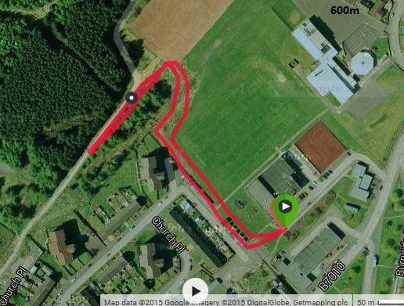
1.5km - TriStar 1
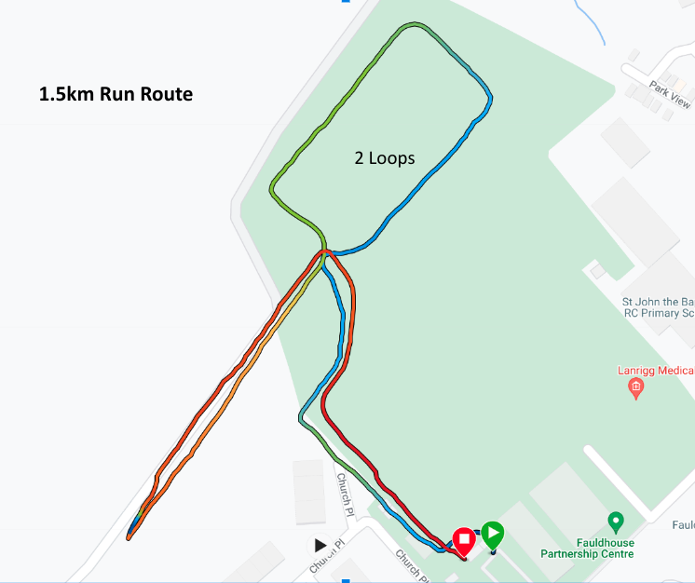

2km - TriStar 2
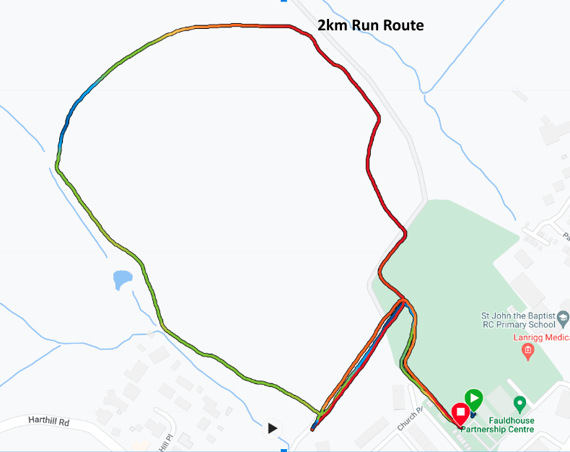
3km - 2 Loop TriStar 3
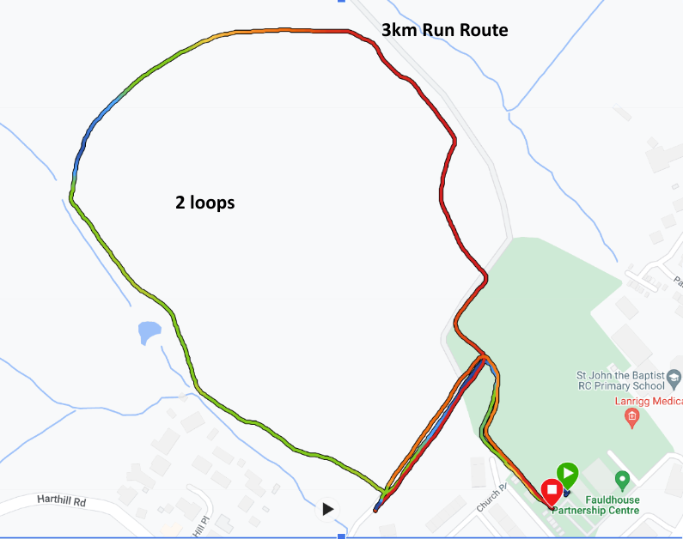
3km - Youth
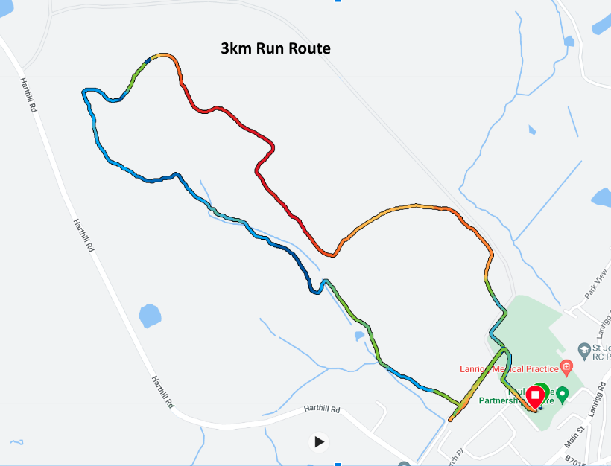

5km - Junior & Adult
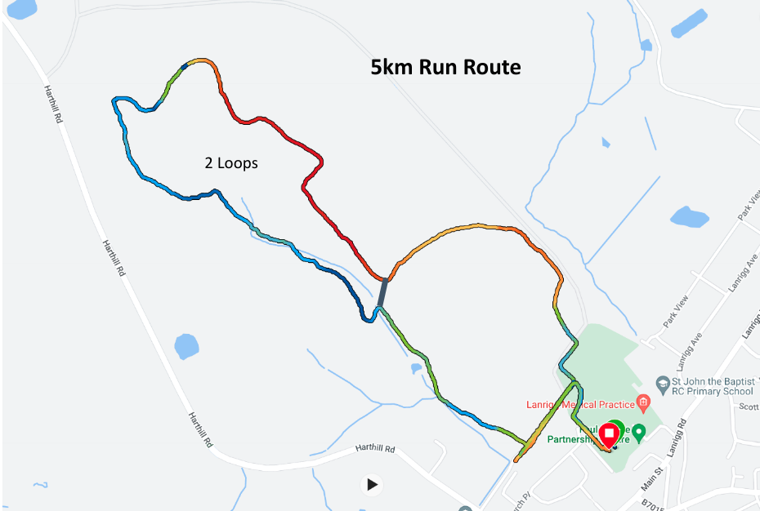

Early Retirement
If for any reason you do not complete the race, please report to either any Marshal or the Race Director as soon as possible.

Finish Area
You will pass through the finish arch in the car park area next to transition and will be awarded your medal.
PLEASE ENSURE YOU RETURN YOUR TIMING CHIP!

Race: After the Event

Timing & Results
You will be given a timing chip at registration; the timing chip MUST be worn on your left ankle throughout the race. Please hand your timing chip back to the marshals at the finish line (or any marshal if you retire early).

We aim to provide a results kiosk to allow competitors to print off their provisional timing results at the finish. The provisional results will not contain age group positions as this is not possible until all competitors have finished.
As well as the timing chips, we will also be operating a manual timing back-up in case any of the timing chips do not read correctly.
The timing team must not be approached with timing queries as this distracts them from the job in hand and may result in the inaccuracy of other results. All disputes/queries will be reviewed after the race, and if necessary before the medal presentation.
Results will be available after the event on the
- WLT Tri website: www.WLTtri.wordpress.com
- Triathlon Scotland Website: www.triathlonscotland.com

Prizes
1st, 2nd and 3rd prizes will be awarded for the following categories for both male and female.
Category | Age Group
TriStar Start | 8 Years
TriStar 1 | 9 – 10 Years
TriStar 2 | 11 – 12 Years
TriStar 3 | 13 – 14 Years
Youth | 15 – 16 Years
Junior | 17 - 19 Years
Adult | 20+ Years

Photos
A photographer will be taking photos throughout the day. You will be able to view your images online on our Facebook page after the event.
If you do not want your photograph taken, please make the registration team know, they will take your race number and pass it to the official photographer.
No photography will not be permitted in the pool and changing areas. This includes by supporters and members of the public. Anyone found to be taking photos in these areas will be removed immediately and images will be deleted.

GOOD LUCK, HAVE FUN AND ENJOY YOUR RACE!

